Check link: <https://market.binamon.org/genesis>

1. Remove Header Menu

Note: Please change the header color / theme

1. Change Navbar Menu
2. 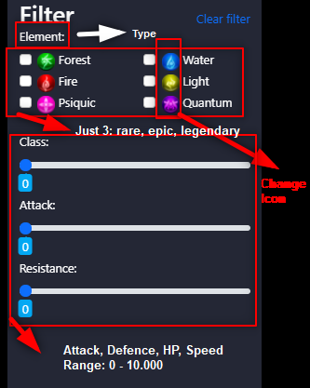Custom filter menu

Note: Custom filter container color

1. Custom Header of Content

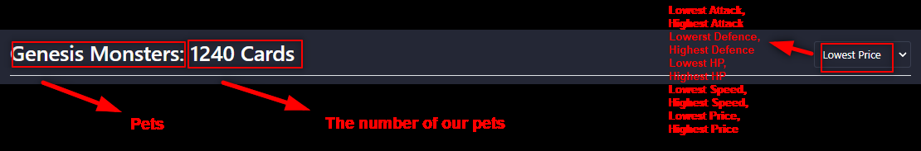

**The number is 12.**

1. 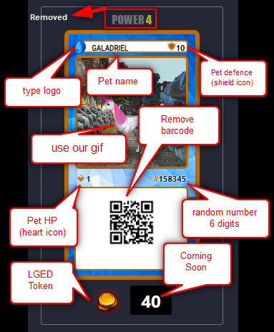Card Custom Design In Pet Menu

